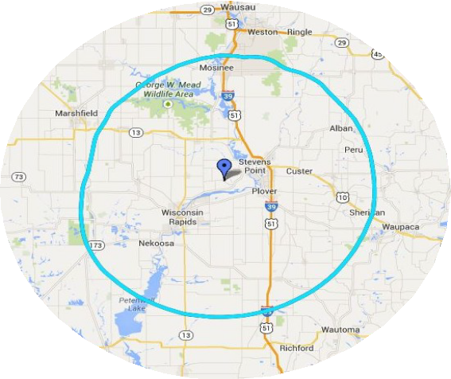
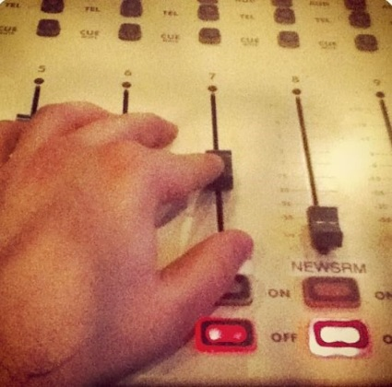
U W S P S t u d e n t R a d i o
WWSP-90FM
1101 Reserve St. (Room 105)
Stevens Point, 54481
2019-2020

Julia DeAngelis
Business & Sales Director

Phone: (715) 346-3755
Cell: (262) 496-5570
Fax: (715) 346-4012
E-mail: wwspbus@uwsp.edu
WWSP - 9 0 F M
CAC Room 105
1101 Reserve Street Stevens Point, WI
WWSP-90FM has been on the air since 1969 and serves the greater Stevens Point area with diverse, alternative music. 90FM can be
tailored to meet your marketing needs.

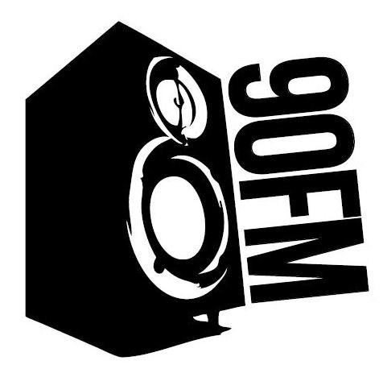
Commercial Donor Announcement
U W S P S t u d e n t R a d i o
90FM
Underwriting
Since 90FM is a non-commercial radio station, we offer underwriting, not advertising. Underwriting, a cost-effective business strategy, helps promote a business while being tax deductible.
90FM.ORG - 89.9FM

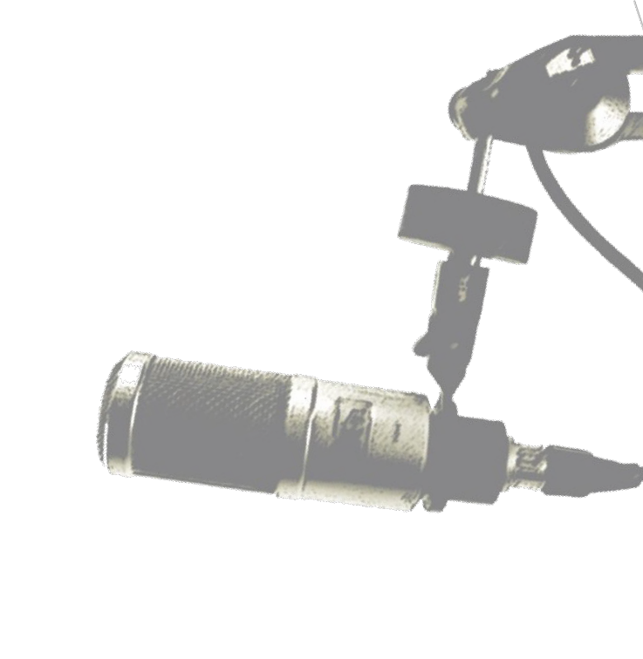

Late Night:
2 A.M. - 6 A.M
- 7 CDA per week (1 per night)
$525 - $1.50 per CDA (Year)

- 14 CDA per week (2 per night)
$980- $1.40 per CDA (Year)

- 28 CDA per week (4 per night)
$1820 - $1.30 per CDA (Year)

- 42 CDA per week (6 per night)
$2310 - $1.10 per CDA (Year)

Specialty weekends include: Reunion Weekend, Wisconsin Weekend, Jazz Fest, Radiothon, Tribute Day, Trivia and Beatles Fest

Specialty and Jazz: Nights and Weekends

1 20 second CDA per week
$128 - $8.50 per CDA (Semester)
$367 - $8.15 per CDA (Year)

2 20 second CDA per week
$243 - $8.10 per CDA (Semester)
$693 - $7.70 per CDA (Year)

3 20 second CDA per week
$347 - $7.70 per CDA (Semester)
$986 - $7.30 per CDA (Year)

5 20 second CDA per week
$544 - $7.25 per CDA (Semester)
$1553 - $6.90 per CDA (Year)

10 20 second CDA per week
$1215 - $6.75 per CDA (Semester)
$2880 - $6.40 per CDA (Year)

15 20 second CDA per week
$1350 - $6.00 per CDA (Semester)
$3881 - $5.75 per CDA (Year)

Sports: $342 – days and times vary (Year)

Why 90FM?

WWSP-90FM, staffed by the students of the University of Wisconsin-Stevens Point, is the
largest student run radio station in the Midwest. With a 60-mile broadcast radius, 90FM would
be pleased to build a professional relationship with your business.

General Programming: 6 A.M. - 6 P.M.

1 20 second CDA per week
$112.50 - $7.50 per CDA(semester)
$355 - $7.10 per CDA (Full Year)

2 20 second CDA per week
$213 - $7.10 per CDA (Semester)
$675 - $6.75 per CDA (Year)

4 20 second CDA per week
$405 - $6.75 per CDA (Semester)
$1280 - $6.40 per Ad (Year)

6 20 second CDA per week
$576 - $6.40 per CDA (Semester)
$1830 - $6.10 per CDA (Year)

Semester is 15 weeks. Full year is 48 weeks. Excludes Specialty weekends.

